

University Grievance Management System

Group Number: 13

Guided By:

Dr. Jignesh Doshi

Project By:

Utsavkumar Vasani 2020004500210083

Bhautik Kathrotiya 2020004500210081

Khushi Satasiya 2020004500210055

GitHub Link:

<https://github.com/Bhautik01/Grievance-management-system>



**CERTIFICATE**

**Enrollment No**:2020004500210083 **Seat No:**

This is to certify that Mr. Utsavkumar A. Vasani of Master of Science (Information Technology) Integrated, Semester 6th , Div B, Roll No 32 has satisfactorily completed his project titled Grievance Management System in S/W Project (050020609) under the supervision of Shanti Verma.

# **Internal Guide** **HOD**

Dr. Shanti Verma Dr. Jignesh Doshi

Date of Submission:

03/05/2023



**CERTIFICATE**

**Enrollment No**:2020004500210081 **Seat No:**

This is to certify that Mr. Kathrotiya Bhautik of Master of Science (Information Technology) Integrated, Semester 6th , Div B, Roll No 30 has satisfactorily completed his project titled Grievance Management System in S/W Project (050020609) under the supervision of Shanti Verma.

# **Internal Guide** **HOD**

Dr. Shanti Verma Dr. Jignesh Doshi

Date of Submission:

03/05/2023



**CERTIFICATE**

**Enrollment No**:2020004500210081 **Seat No:**

This is to certify that Mr. Khushi Satasiya of Master of Science (Information Technology) Integrated, Semester 6th , Div B, Roll No 01 has satisfactorily completed his project titled Grievance Management System in S/W Project (050020609) under the supervision of Shanti Verma.

# **Internal Guide** **HOD**

Dr. Shanti Verma Dr. Jignesh Doshi

Date of Submission:

03/05/2023

Certificate of Originality

This is to certify, that the project work submitted by us titled

Grievance Management System is an outcome of my/our independent and original work. I/we assure that this project is not copied from any other person’s work (published/unpublished), and has not previously submitted for assessment either at University or elsewhere. I/we confirm that, I/we have read and understood the rules and regulations on plagiarism in LJU.

|  |  |  |  |
| --- | --- | --- | --- |
| **Sr. No.** | **Enrollment No.** | **Name of the student** | **Signature** |
| 1 | 2020004500210083 | Utsavkumar A. Vasani |  |
| 2 | 2020004500210081 | Kathrotiya Bhautik |  |
| 3 | 2020004500210055 | Khushi Satasiya |  |

Commitment form

we assure that following are the components on which we worked in the said project titled Grievance Management System. Further we confirm that, we have read and understood the rules and regulations of UFM in LJU.

# Student 1

Enrollment No. :2020004500210083 Division:B Roll No : 30

Name of the student: Utsavkumar A. Vasani

|  |  |
| --- | --- |
| ***Components worked on (Not overlapping or common across members)*** | |
| 1. | 2. |
| 3. | 4. |
| 5. | 6. |
| 7. | 8. |
| 9. | 10. |
| Date: | Signature: |

# 

# Student 2

Enrollment No. :2020004500210081 Division:B Roll No : 30

Name of the student: Kathrotiya Bhautik

|  |  |
| --- | --- |
| ***Components worked on (Not overlapping or common across members)*** | |
| 1. | 2. |
| 3. | 4. |
| 5. | 6. |
| 7. | 8. |
| 9. | 10. |
| Date: | Signature: |

# Student 3

Enrollment No. :2020004500210055 Division:B Roll No : 01

Name of the student: Khushi Satasiya

|  |  |
| --- | --- |
| ***Components worked on (Not overlapping or common across members)*** | |
| 1. | 2. |
| 3. | 4. |
| 5. | 6. |
| 7. | 8. |
| 9. | 10. |
| Date: | Signature: |

Index

# 1.Introduction……………………………………………………………

# Existing System …………………………………………………..................................

# Need for the New System …………………………………………….…......................

# Objective of the New System …………………………………………........................

# Problem Definition …………………………………………………….......................

# Core Components ……………………………………………………………………......

# Project Profile ……………………………………………………………………………..

# Advantages of the Proposed System ………………….………………......................

1.8 Limitations of the Proposed System…………………………………………………….

2.Require Determination & Analysis

2.1 Requirement Determination………………………………………………………………

2.2 Targeted Users …………………………………………………………………………….

# 3.System Design…………………………………………………………

# Use Case Diagram ………………………………………………………………………….

# Activity Diagram ……………………………………………………………………………

# Sequence Diagram …………………………………………………………………………

# Class Diagram ………………………………………………………………………………

# Data Dictionary ………………………………………………………..............................

# 4.Development **…**……………………………………………………..................

# 4.1 Screenshots ………………………………………………………….………………………

# 5.Agile Documentation…..……………………………………………....

5.1 Agile Project Charter………………………………………………………………………..

5.2 Agile Project Plan…………………………………………………………………………..

# 6.Bibliography ………………………………………………………….

1. INTRODUCTION

A university grievance management system is a process that universities use to handle student, faculty, and staff complaints and concerns effectively. The system typically includes a set of policies and procedures that ensure grievances are handled in a timely, fair, and confidential manner.

The primary goal of a university grievance management system is to provide an avenue for students, faculty, and staff to voice their grievances and have them resolved in a fair and equitable manner. It helps to create a positive and supportive university community that values feedback and continuous improvement.

* 1. **Existing System :**

Typically, universities have a designated office or department responsible for receiving and handling grievances. This may be called the Office of Student Affairs, Office of Human Resources, or Office of Faculty Affairs, depending on the nature of the grievance.

* 1. **Need For The New System :**

While the existing university grievance management systems aim to provide a fair and transparent process for addressing grievances, there may be a need for a new system to address some of the limitations of the current system.

* 1. **Objective Of The New System :**

The objective of a new university grievance management system is improving responsiveness, Enhancing transparency, Ensuring consistency, increasing accessibility, Promoting accountability and Facilitating continuous improvement.

* 1. **Problem Definition :**

In current scenario, students have to go to college premises to register complaint or to get status of registered complaint. Also college administrations have to allocate human resource to examine and resolve the complaint. These make whole process tedious. These problems can lead to a lack of trust in the grievance management system and can make it difficult to resolve complaints effectively.

* 1. **Core Component :**

**Student:** In grievance management system student can login the system and register their complaints and view their complain history. And student can raise complaint and gives the feedback. Student can change their password and logout or exit the system.

**Admin:** Admin can login and change their password and admin can logout or exit the system. Admin also manage an organizational structure of university and manage a user. Admin can view pending and closed complaints

**Problem Solver:** problem solver can login and change their password and problem solver can logout or exit the system. Problem solver checks a grievance and try to solve grievance and can complaint to the upper level of organizational structure. After resolving a grievance they notify to the Student and checks a feedback. They can manage their profile and check pending status of grievance.

* 1. **Project Profile :**

**Student:**

1. Registration
2. Login
3. Forgot Password
4. Reset password
5. Post Their Complain
6. Check The Status Of Complain
7. Can Send Feedback
8. Manage Profile

**Admin:**

1. Login
2. Forgot Password
3. Reset password
4. Can see Complains
5. Can manage User
6. Can Manage user’s Data
7. Can Manage Complains
8. Mange Profile
9. Check A Feedback

**Faculty:**

1. Registration
2. Login
3. Forgot Password
4. Reset password
5. Can see Complains
6. Solves Complains
7. Change The status of Complain
8. Ends Unwanted Complain Forcefully
9. Can Pass Complain To the Upper Level Of Organization
10. Manage Profile
    1. **Assumptions and Constrains :**

We are assuming that user have a computer devices. We are assuming that user is a capable to interact with computer devices for grievance. We are assuming that they have proper network connections. We cannot use system without having computer and internet Connections.

* 1. **Advantages and limitations :**

**Advantages :**

* The new system will manage the problem and their status.
* No possibility of communication gap.
* Instant report generation for any complaint can be obtained.
* New system will ensure smooth side between the management and students.

**Limitations :**

* The current system is manual and time consuming.
* Communication gap is the biggest problem in such a system.
* The students / faculty may not be aware/conveyed the problems status.

1. REQUIREMENT DETERMINATION & ANALYSIS
   1. **Requirement Determination & User Requirements:**

The requirements for a college grievance management system include a user-friendly interface, accessibility, security, efficiency, customization, reporting and analytics, mobile compatibility, transparency, integration with other systems, and user training. The system should allow for easy filing and tracking of complaints, with clear communication and updates. It should also have robust security measures in place to protect users' personal information. Additionally, the system should provide transparency and integrate with other college systems to ensure accurate and up-to-date data. Finally, users should receive adequate training on how to use the system effectively.

* 1. **Targeted User :**

Our system has three types of users they are as follows:

1. Admin
2. Student
3. Members of organizations
4. SYSTEM DESIGN
   1. **Use case diagram :**

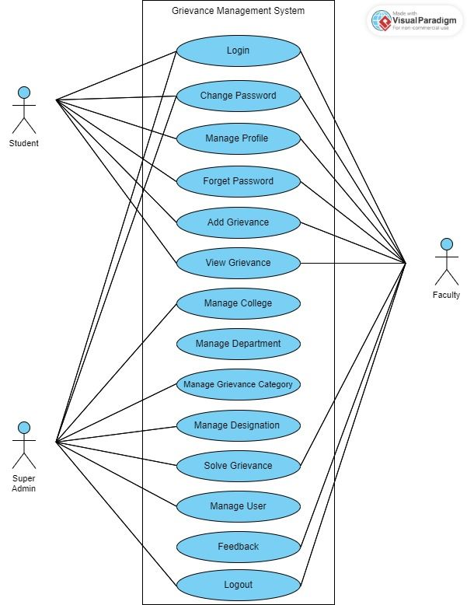

* 1. **Activity Diagram :**

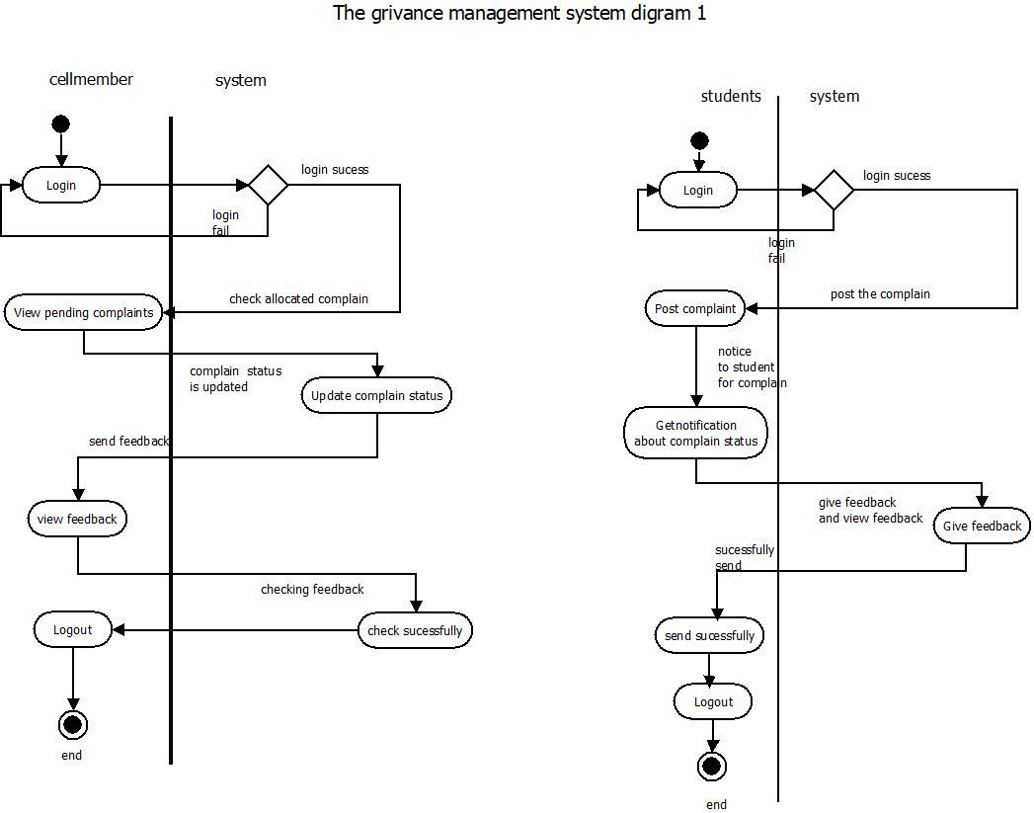

Students

Orgenization member

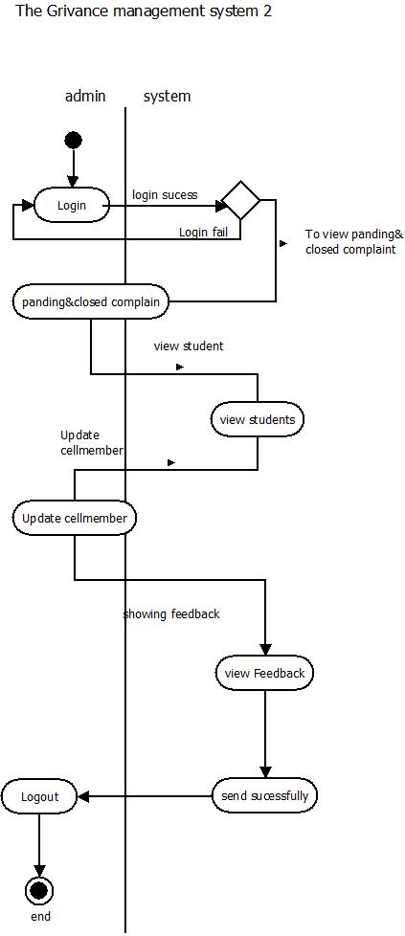

* 1. **Class Diagram :**

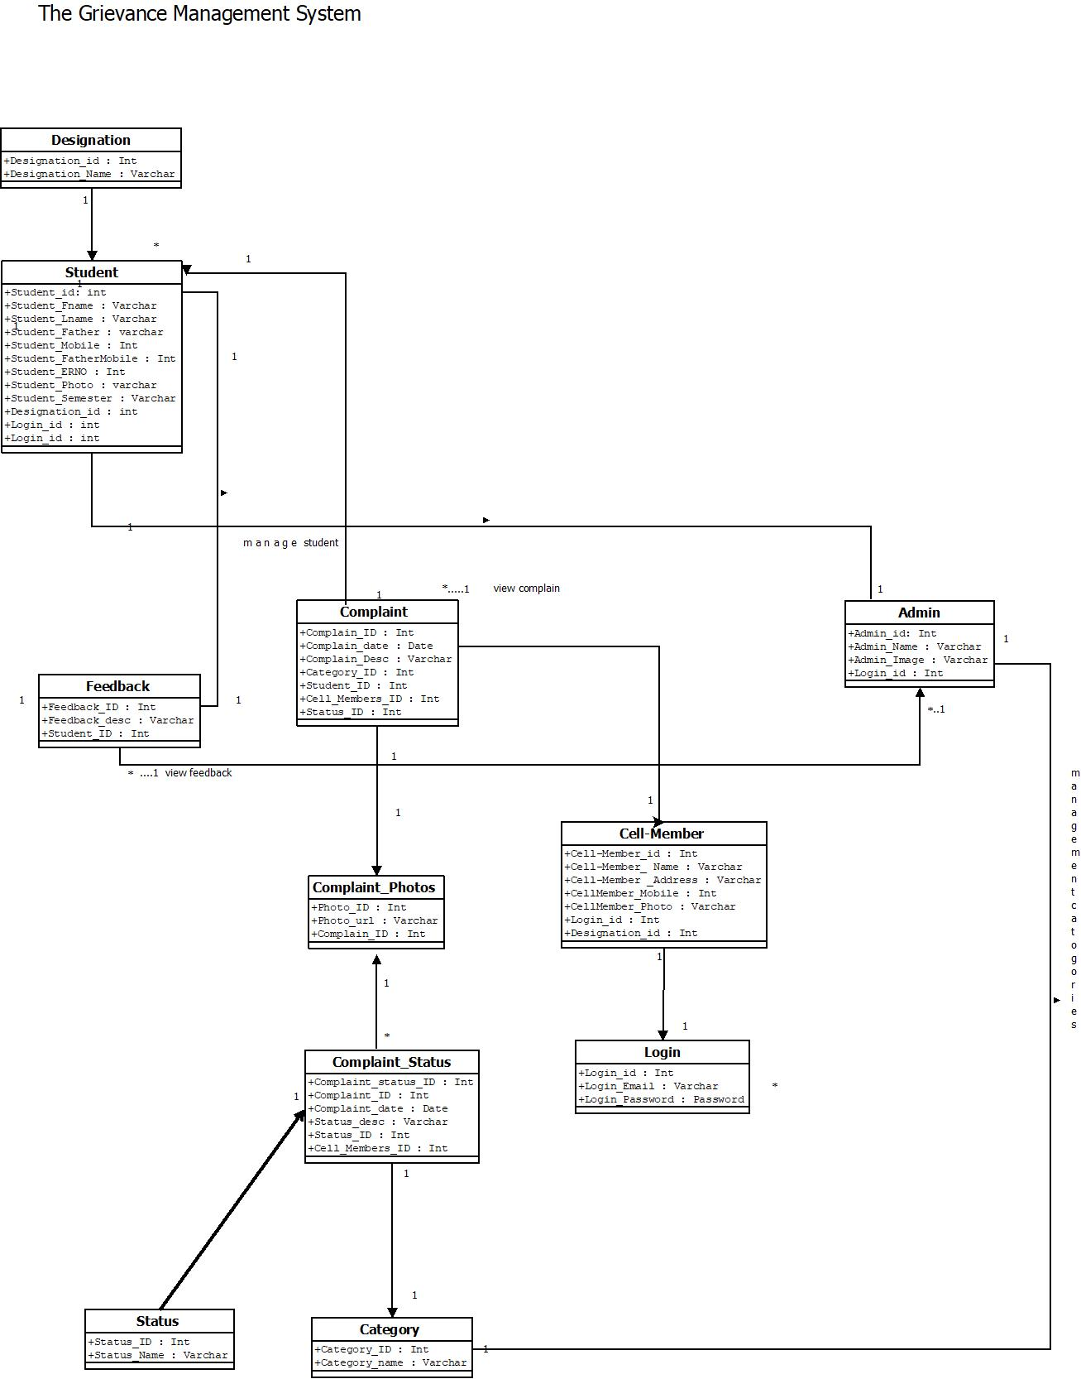

* 1. **Sequence Diagram :**

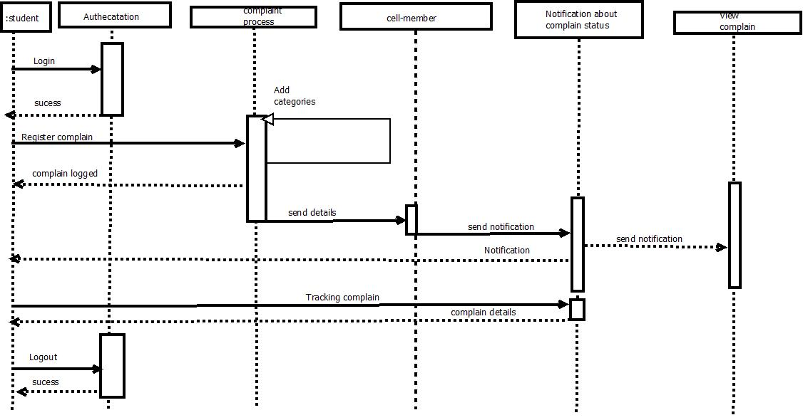

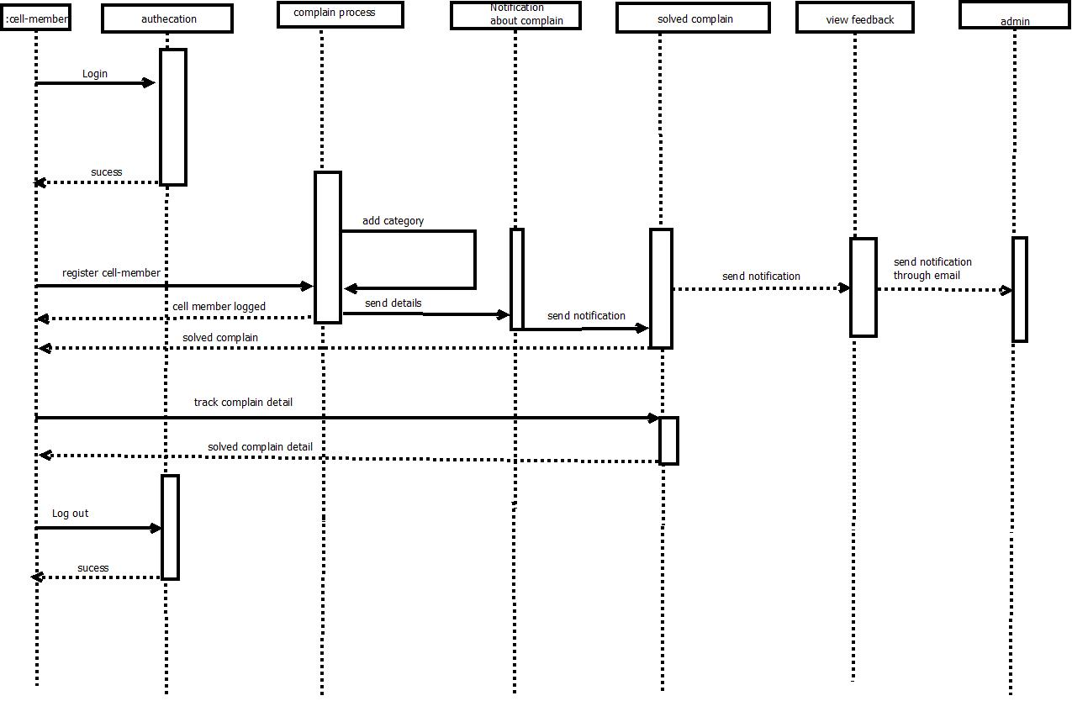

* 1. **Data Dictionary :**

1. **Table Name:** College

|  |  |  |  |  |
| --- | --- | --- | --- | --- |
| Field Name | Data Type | Constraint | Description | Sample Data |
| id | Int | Primary key | College identification | 1001 |
| collegeName | Varchar2(30) | Not Null | Name Of College | “LJ institute of Computer Application” |
| College Description | Varchar2(50) | Not Null | Details Of College | L.J. Institute of Engineering and Technology |
| College Image | Varchar2 | Not Null | Upload Image | college/logo2.png |

1. **Table Name:** Department

|  |  |  |  |  |
| --- | --- | --- | --- | --- |
| Field Name | Data Type | Constraint | Description | Sample Data |
| id | bigInt(20) | Primary key | Identification of department | 2001 |
| departmentname | Varchar2(200) | Not Null | Name of department | MCA |
| semester | Int(11) | Not Null | No of semester | 6 |
| college_id | Bigint(20) | Foreign key | Enter college reference | 1 |

1. **Table Name:** Designation

|  |  |  |  |  |
| --- | --- | --- | --- | --- |
| Field Name | Data Type | Constraint | Description | Sample Data |
| id | bigInt(20) | Primary key | Identification of designation | 3001 |
| designationName | longtext | Not Null | Enter designation name | 6 |
| power | Int(11) | unique | Enter managerial power | 1 |

1. **Table Name:** Grievance Type

|  |  |  |  |  |
| --- | --- | --- | --- | --- |
| Field Name | Data Type | Constraint | Description | Sample Data |
| id | bigInt(20) | Primary key | Identification of Grievance type | 1 |
| typeName | longtext | Not null | Type of grievance | Acadmic |

1. **Table Name:** Complain

|  |  |  |  |  |
| --- | --- | --- | --- | --- |
| Field Name | Data Type | Constraint | Description | Sample Data |
| ComplainId | Int | Primary key | Identification of complain | 5001 |
| fromId | Int | Foreign key | Identification of Sender | 6001 |
| toId | Int | Foreign key | Identification of Receiver | 6002 |
| Abut | Varchar2(100) | Not Null | Subject Of Complain | Educational |
| complain | Varchar2(100) | Not Null | Message Of Complain | “dustbin is not proper” |
| complainDate | Date | Not Null | Date of Complain | 27/03/2023 |
| Status | Int | Not Null | Completed, Pending, Dismissed | 0,1,2 |
| Solution | Varchar2(200) | Null | How Complain Solved | “we have put new dustbin” |
| solutionDate | Date | Null | Date of Solution | 30/03/2023 |

1. **Table Name:** Users

|  |  |  |  |  |
| --- | --- | --- | --- | --- |
| Field Name | Data Type | Constraint | Description | Sample Data |
| id | Bigint(20) | Primary key | Identification of user | 1 |
| image | varchar(100) | Not Null | Upload image | users/Pngtreeuser_  vector_avatar_  4830521_MTfWIbh.pn... |
| userName | longtext | Not Null | Name of user | Utsav |
| surName | longtext | Not Null | Surname of user | Vasani |
| fatherName | longtext | Not Null | Fathername of user | Ashokbhai |
| semester | int(11) | Null | Enter semester | 6 |
| phoneNumber | varchar(10) | Not Null | Enter mo | 9909520532 |
| email | varchar(254) | Not Null | Enter email | utsavvasani@gmail.com |
| address | varchar(100) | Not Null | Enter address | surat |
| College_id | bigint(20) | Foreign key | Enter college ref. | 1 |
| Department_id | bigint(20) | Foreign key | Enter dept id. | 1 |
| Designation_id | bigint(20) | Foreign key | Enter designation id. | 1 |

**7.Table Data:** Complain data

|  |  |  |  |  |
| --- | --- | --- | --- | --- |
| Field Name | Data Type | Constraint | Description | Sample Data |
| id | Bigint(20) | Primary key | Identification of user | 1 |
| complainCode | varchar(100) | Not Null | Upload image | users/Pngtreeuser_  vector_avatar_  4830521_MTfWIbh.pn... |
| image | longtext | Not Null | Name of user | Utsav |
| description | longtext | Not Null | Surname of user | Vasani |
| remark | longtext | Not Null | Fathername of user | Ashokbhai |
| grivenceDate | int(11) | Null | Enter semester | 6 |
| solvingDate | varchar(10) | Not Null | Enter mo | 9909520532 |
| status | varchar(254) | Not Null | Enter email | utsavvasani@gmail.com |
| Category_id | varchar(100) | Not Null | Enter address | surat |
| nameOfComplainant_id | bigint(20) | Foreign key | Enter college ref. | 1 |
| nameOfSolver_id | bigint(20) | Foreign key | Enter dept id. | 1 |

1. Development :
   1. **Screenshorts:**

LOGIN

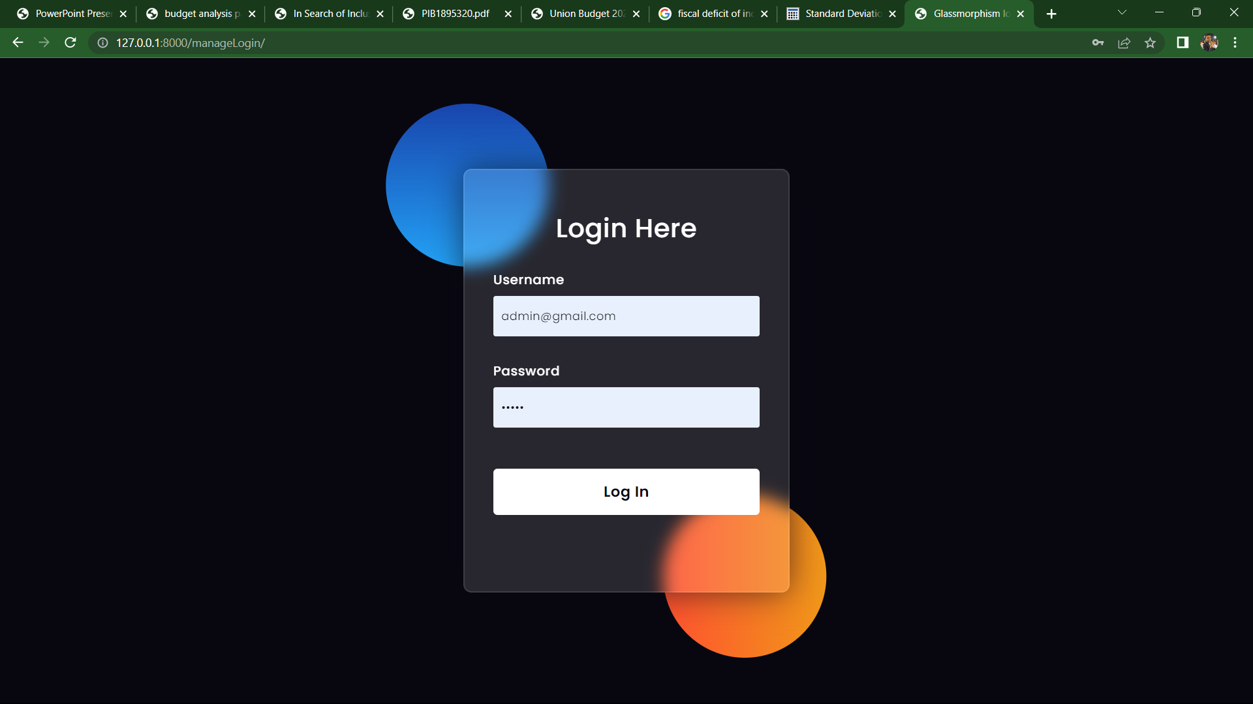

USERS

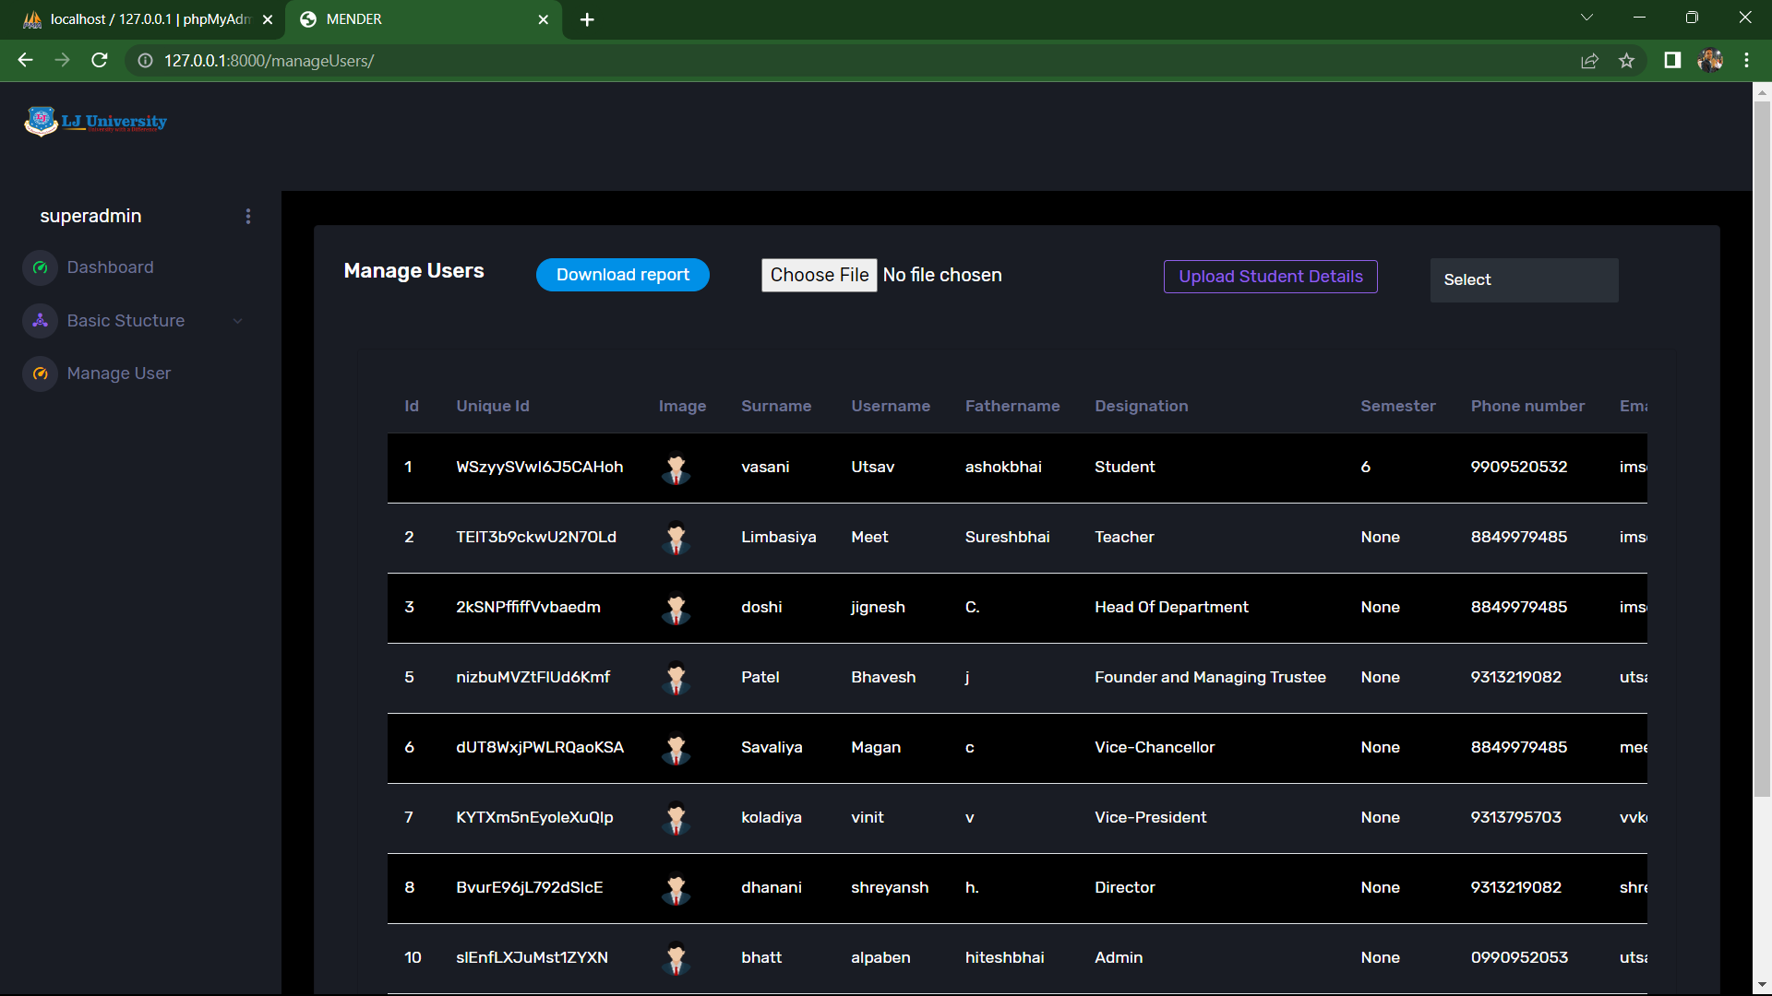

COLLEGES

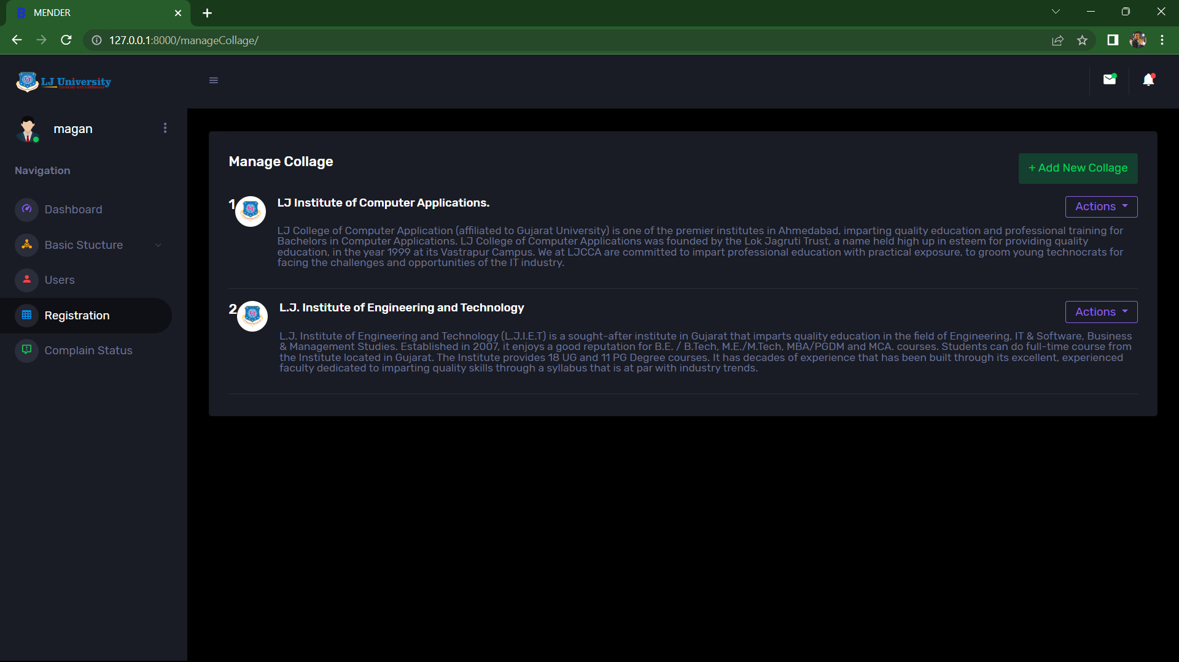

DESIGNATION

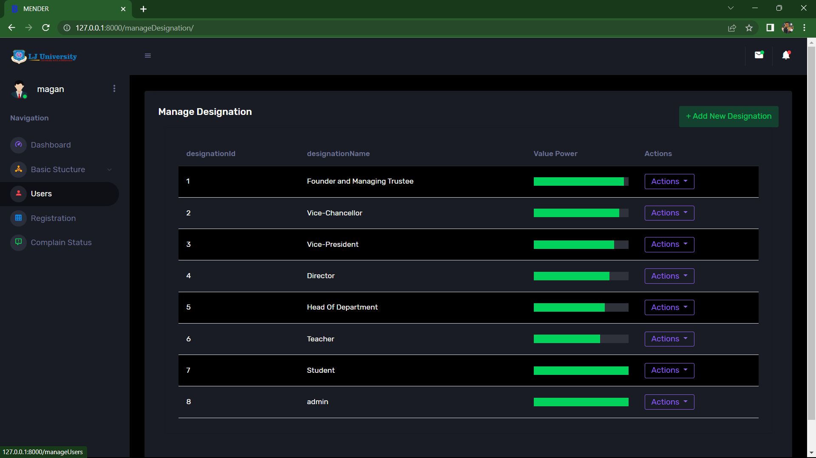

DEPARTMENT

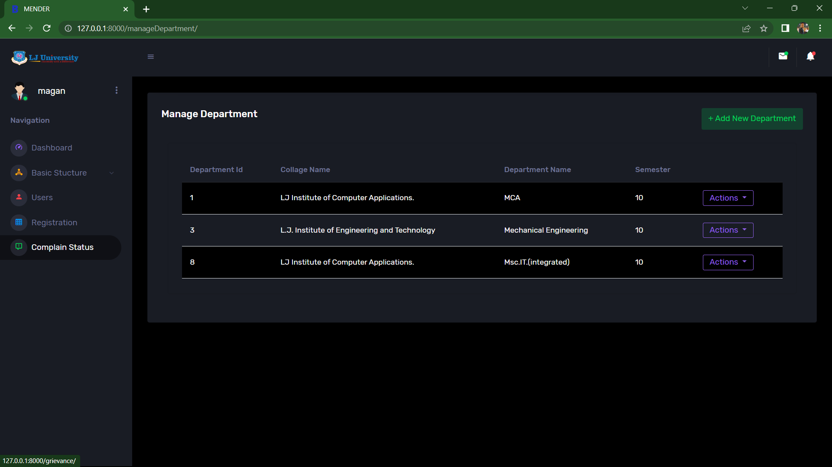

GRIEVANCE CATEGORY

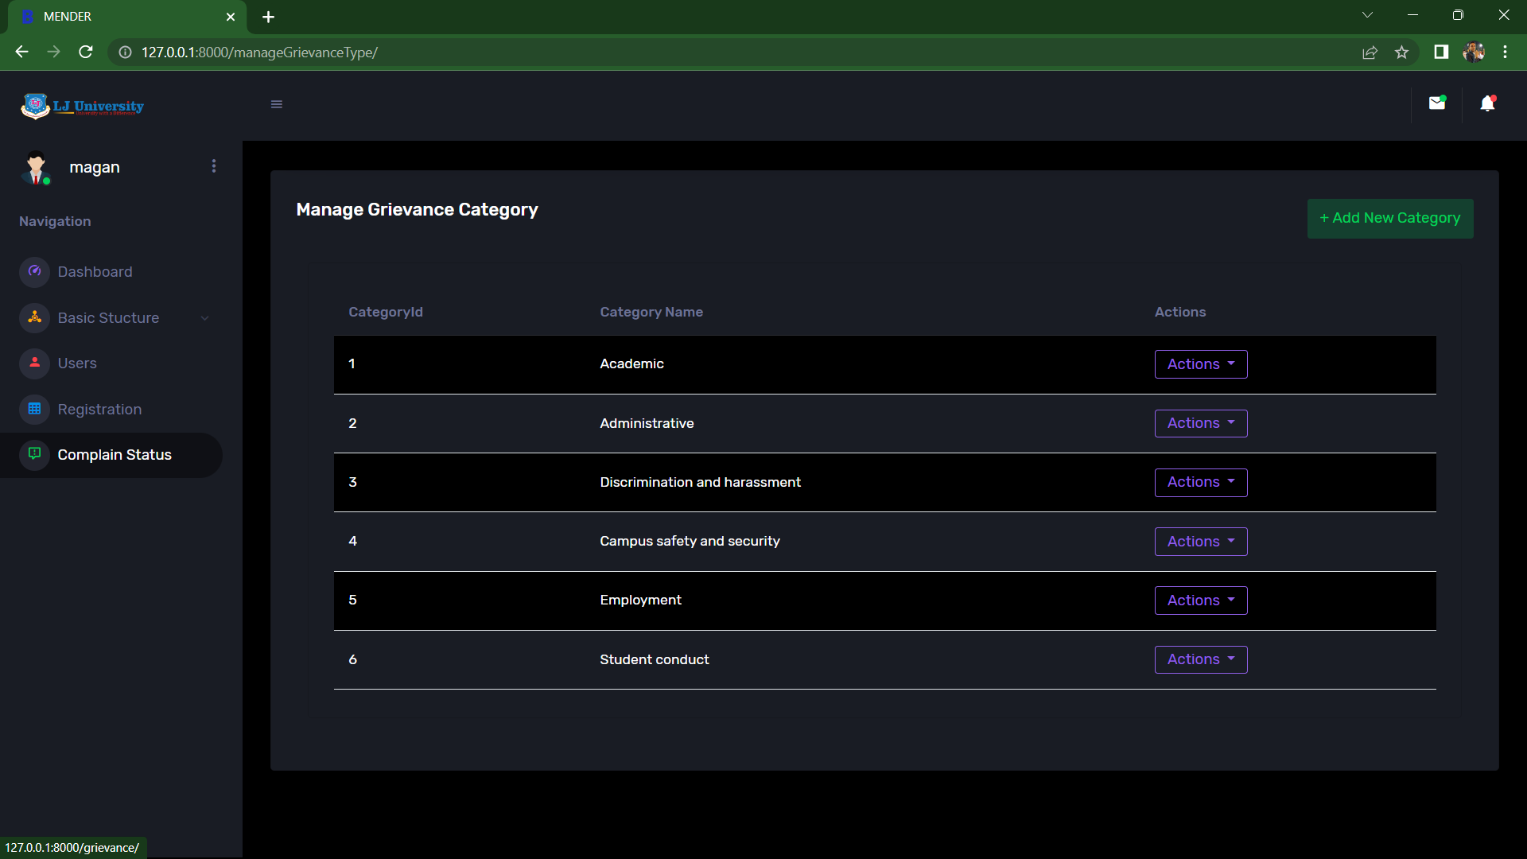

GRIEVANCE FORM

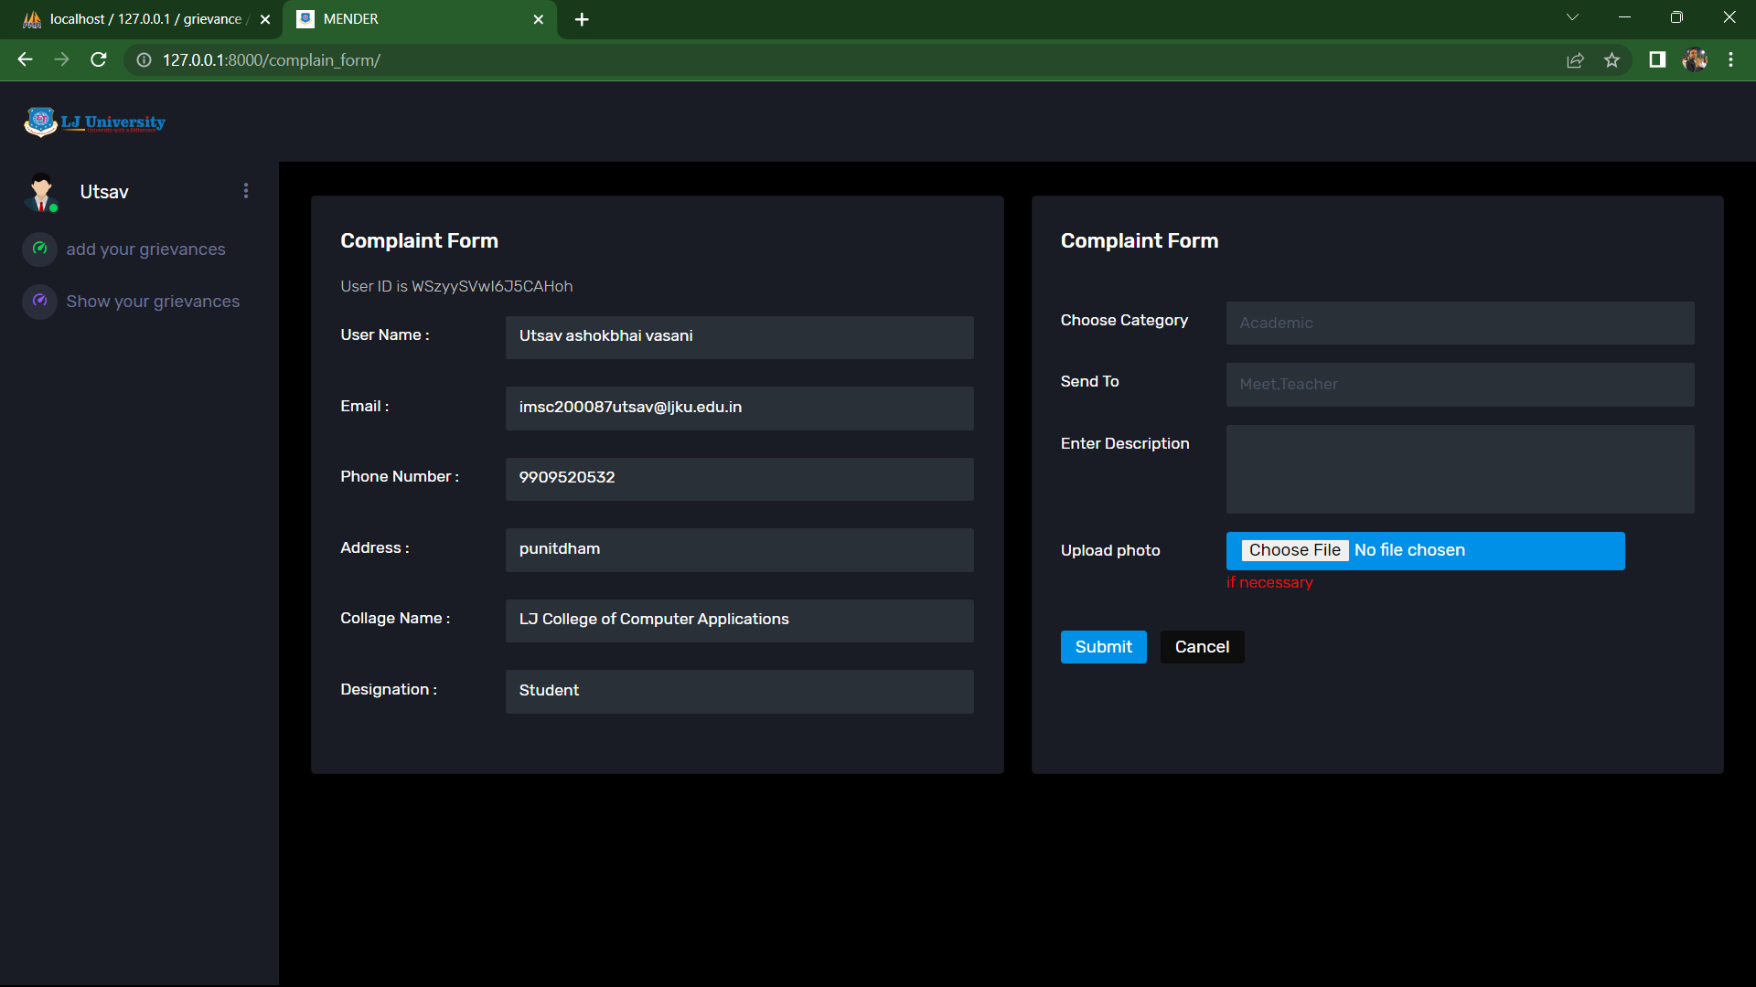

COMPLAIN INFORMATION

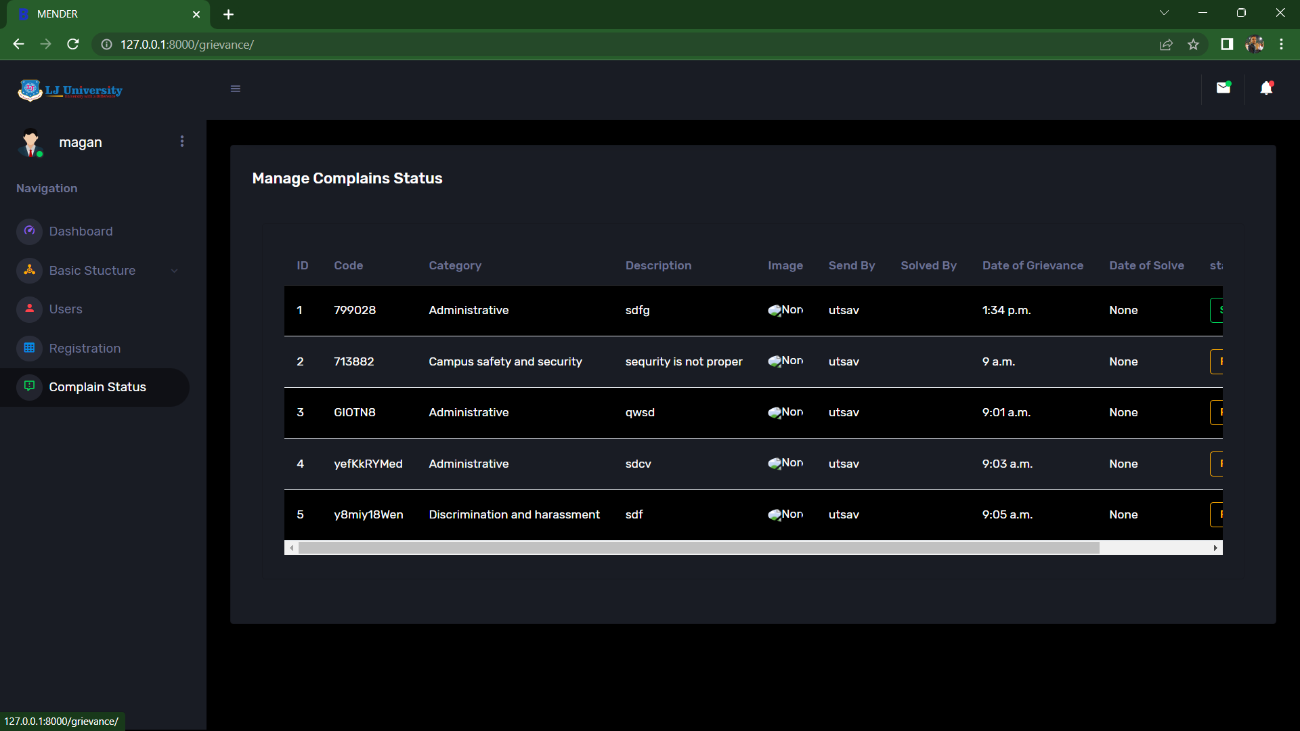

PROFILE

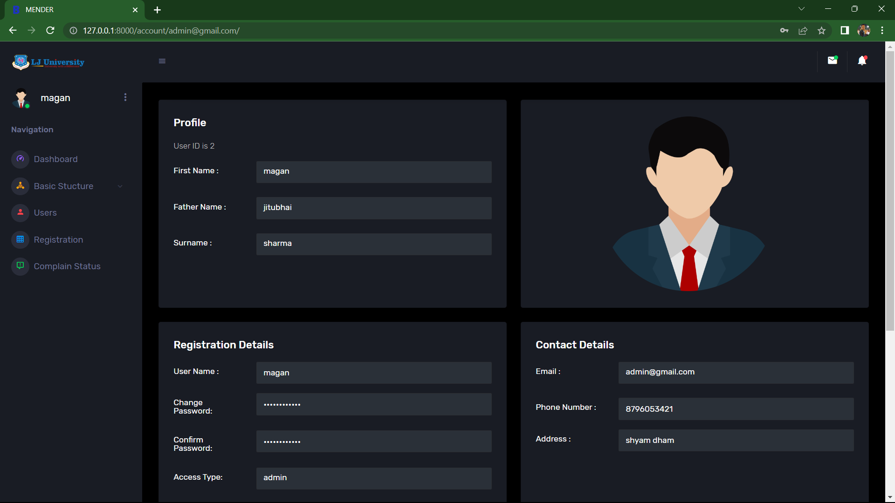

ADMIN DASHBORD

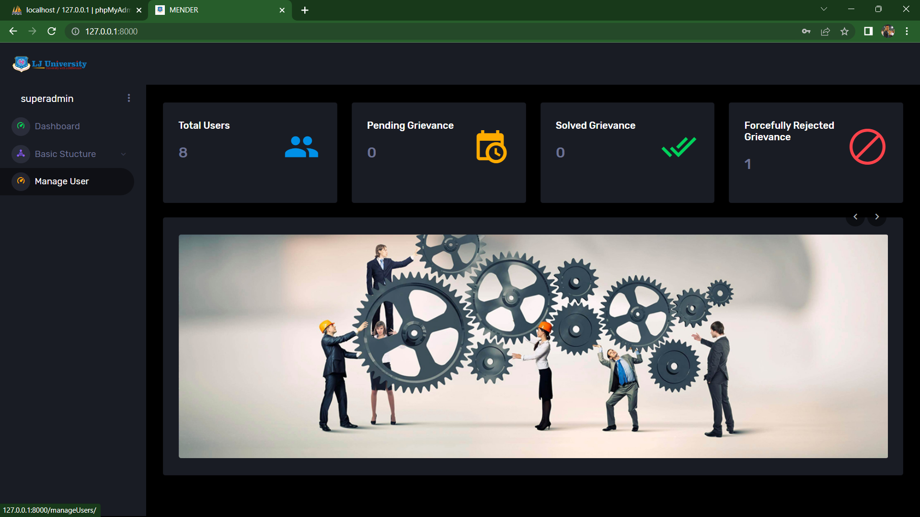

FORGOT PASSWORD

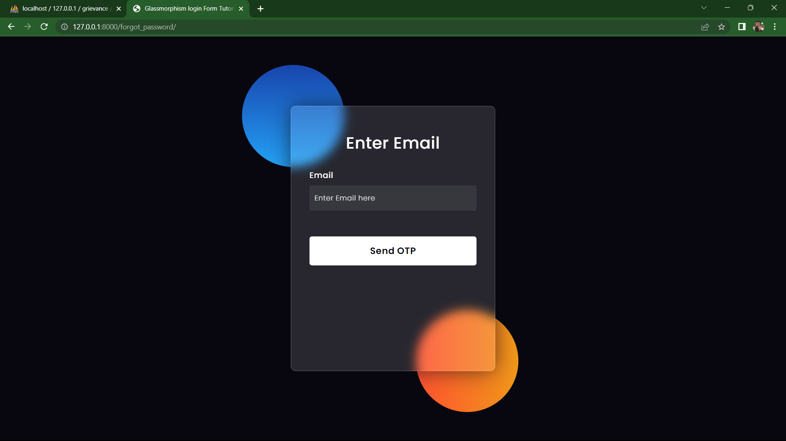

CHANGE PASSWORD

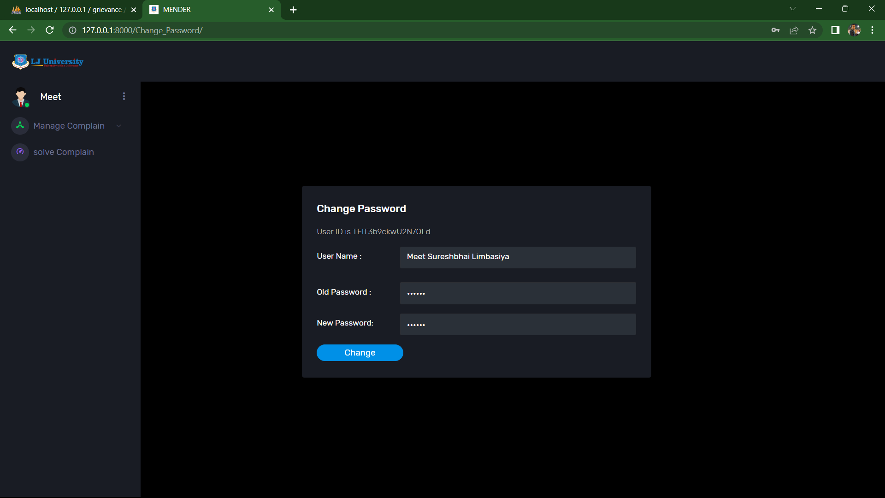

FEEDBACK

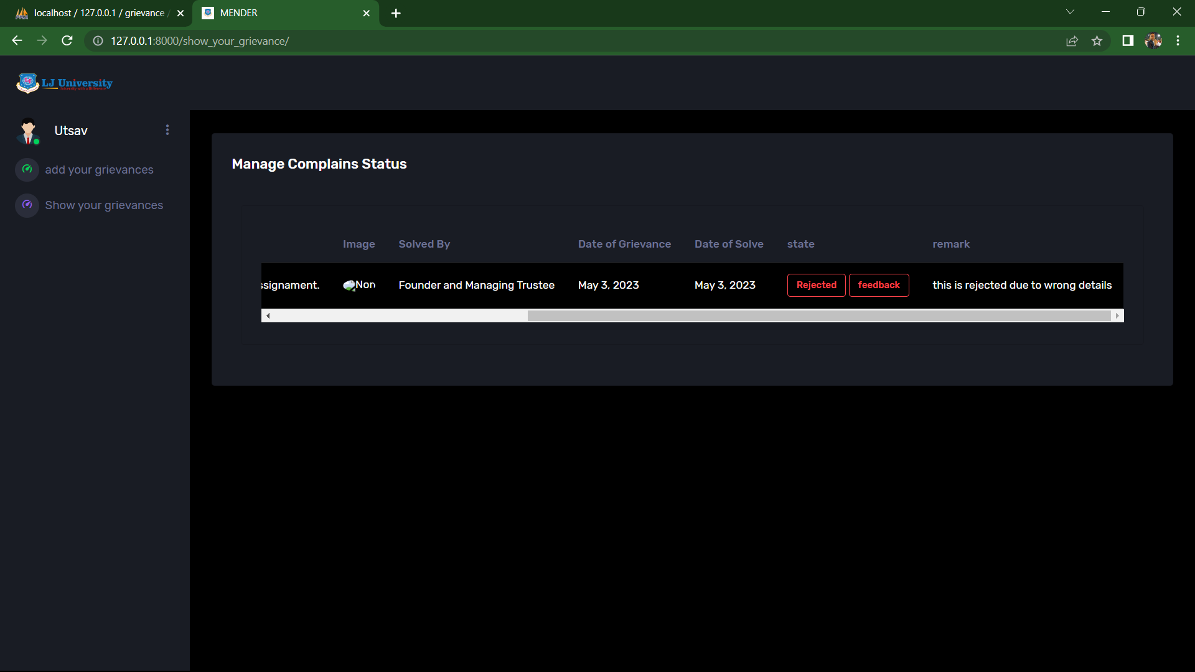

1. Agile Documentation

**5.1 Agile project charter :**

|  |  |
| --- | --- |
| **General Project Information** |  |
| Project Name | Grievance Management System |
| Project Sponsor | LJ Institute of Computer Application |
| Project Manager | Dr. Shanti Verma |
| Stakeholders | LJ Institute of Computer Application |
| Expected Start Date |  |
| Expected Completion Date |  |

|  |  |
| --- | --- |
| **Project Details** |  |
| Mission | The Grievance management system aims to provide a platform for students and faculty members to lodge and resolve complaints efficiently. The system aims to streamline the grievance redressal process, promote transparency, and enhance communication between students and college authorities. |
| Vision | The project vision for a grievance management system is to create a platform that facilitates effective and efficient management of student grievances within the college. This system should provide a user-friendly interface for students to register their complaints and for the college administration to address and resolve them in a timely and transparent manner. |
| Scope | The project scope for a grievance management system involves creating a software solution that enables students and faculty to submit and track complaints related to academic or non-academic matters. It should have a user-friendly interface for complaint submission, department assignment, and record-keeping. The system may also have features like analytics and reporting to help college administrators address recurring issues |
|  |  |

**Agile schedule for your Grievance Management System website:**

Week 1:

* User stories: Identify the user stories for the system. These could include features like filing a grievance, assigning it to a department, notifying the concerned authorities, tracking the status, and resolving the issue.
* Wireframes: Create rough sketches of the system's user interface, based on the user stories.
* Project backlog: Create a list of tasks that need to be completed for the first sprint.

Week 2:

* Sprint planning: Plan the tasks to be completed during the first sprint, based on the backlog.
* Architecture diagrams: Create diagrams that show the system's overall architecture and how the various components will interact with each other.
* Technical documentation: Write technical documentation for the components that will be developed during the first sprint.

Week 3:

* Sprint review: Review the tasks completed during the first sprint and update the backlog for the next sprint.
* User documentation: Write documentation that explains how to use the system from the end-user's perspective.
* Test cases: Create test cases for the components developed during the first sprint. Sprint 4 (2 weeks):

Week 4:

* Sprint planning: Plan the tasks to be completed during the second sprint, based on the updated backlog.
* Code documentation: Document the code developed during the first sprint.
* Integration testing: Test the integration between the components developed during the first sprint.

**Agile Project Plan:**

* Agile User Stories

|  |  |  |  |
| --- | --- | --- | --- |
| **User Story ID** | **As a**  **<type of user>** | **I want to**  **<perform some task>** | **so that I can <achieve some goal>** |
| 1 | Super Admin | Login and Logout | Manage system and services for user’s satisfaction |
| 2 | Super Admin | Manage College | Add and Manage details of college |
| 3 | Super Admin | Manage  Department | Add and Manage details of Department According to College |
| 4 | Super Admin | Manage Designation | Add hierarchy of member of organization |
| 5 | Super Admin | Manage Users | Add and Manage Users |
| 6 | Super Admin | Generate Reports | Generate the Reports of Grievance |
| 7 | Staff Of Institute | Login and Logout | Manage system and services for user’s satisfaction |
| 8 | Staff Of Institute | Add Grievance | Have a unique profile to manage |
| 9 | Staff Of Institute | Solve Grievance | Purchase product from the system |
| 10 | Staff Of Institute | Manage Profile | Know the details of product in a sec |
| 11 | Staff Of Institute | Manage Department | Update address if I shift my place |
| 12 | Student | Login and Logout | Login With Unique Username or password |
| 13 | Student | Add Grievance | Submit Complaint to particular person with details |
| 14 | Student | Check Status | Check complain status (pending, forcefully rejected, solved) |
| 15 | Student | Give Feedback | Student says his Experience or Satisfaction |
| 16 | Student | Manage Profile | Update mobile number, Address, Password |

Agile test plan :

|  |  |  |  |  |  |  |  |  |
| --- | --- | --- | --- | --- | --- | --- | --- | --- |
| **Project Name** | | **Grievance Management system** | | | **Device** | | Laptop | |
| **Test Case Id** | | 1 | | | **Test Title** | | Login, Manage website | |
| **Module Name** | | Login, Manage website | | | **Tested By** | |  | |
| **Priority** | | High | | | **Execution Date** | |  | |
| **Test** | **Test Step** | | **Action** | **Expected Result** | | **Actual Result** | | **Pass** |
| 1 | Open login page | | Open  Login  Page | Open Login Page | | Login Page Opened | | Yes |
| 2 | Enter Id and  Password of admin | | Enter Data | Validate User | | Admin data Validated | | Yes |
| 3 | Do login | | Click on login button | User should logged in | | Login successful | | Yes |
| 4 | After successful login, navigate to  Manage Company | | Open Company  page | Open  Company  Page | | Company Page Opened, added the data and displayed on user site | | Yes |

1. Conclusion

The answer concludes that a grievance management system is necessary for effectively addressing student complaints and grievances. Such a system should provide a structured process that ensures fairness, impartiality, and confidentiality while adhering to due process. Additionally, the system should be continuously monitored and evaluated for its effectiveness. Ultimately, implementing an effective grievance management system can enhance the learning environment and improve the overall college experience for students.

1. Bibliography

* **WWW.W3SCHOOOLS.COM**
* **WWW.W3LAYOUTS.COM**
* **WWW.FREESOURCECODE.COM**
* **WWW.MATERIALIZECSS.COM**
* **WWW.W3RESOURCE.COM**
* **WWW.STACKOVERFLOW.COM**
* **WWW.TUTORIALSPOINT.COM**
* **WWW.JAVATPOINT.COM**